Same-Line Internal Rhyme

🔄 What is Same-Line Internal Rhyme
# Source: AI Source: Provided by: [Data Path: Persons Table -> ID Column: 1, Name_En Column: Motasem Essam] -> From: [Chatgpt (GPT-4-turbo)] on [8/2/2025]
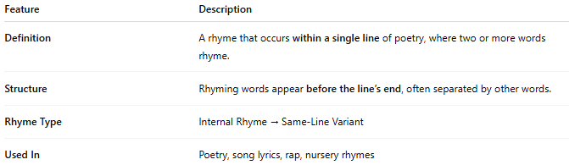
Feature | Description
Definition | A rhyme that occurs within a single line of poetry, where two or more words rhyme.
Structure | Rhyming words appear before the line’s end, often separated by other words.
Rhyme Type | Internal Rhyme → Same-Line Variant
Used In | Poetry, song lyrics, rap, nursery rhymes

📝 Examples:
# Source: AI Source: Provided by: [Data Path: Persons Table -> ID Column: 1, Name_En Column: Motasem Essam] -> From: [Chatgpt (GPT-4-turbo)] on [8/2/2025]
I went to town to buy a gown.
He felt so low, but wouldn’t let it show.
The light was bright, it pierced the night.

🎭 Effect in Poetry:
# Source: AI Source: Provided by: [Data Path: Persons Table -> ID Column: 1, Name_En Column: Motasem Essam] -> From: [Chatgpt (GPT-4-turbo)] on [8/2/2025]
- Creates a musical, rhythmic effect
- Adds flow and momentum to a line
- Useful in raps, chants, and playful verse
- Helps draw emphasis to key words or emotions

✅ When to Use:
# Source: AI Source: Provided by: [Data Path: Persons Table -> ID Column: 1, Name_En Column: Motasem Essam] -> From: [Chatgpt (GPT-4-turbo)] on [8/2/2025]
- To keep short lines engaging
- When you want rhyming without end-of-line constraints
- In spoken word and performance poetry to heighten impact

